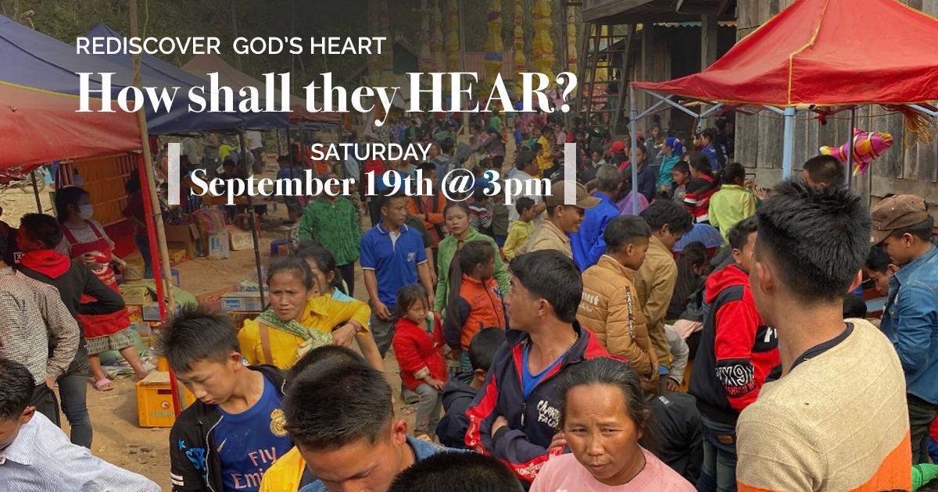

Hosted at Immanuel Bible Church
5433 N. Center Road
Saginaw, MI

Session 1 – God's heart for lost nations.

Trace the Biblical thread of God's heart for the nations from Genesis to Revelation. This will change how you read your Bible.

Session 2 – How God transformed one nation.

Hear from one woman among a people cut off from the Gospel of Jesus Christ. Hear how God used a church to reach her desperate people. You won't want to miss this rare chance.

Session 3 – How God continues to reach the nations

Explore how God can mobilize your church to impact lost nations for eternity.

